The theme for the investigation is a human has taken a bite of a fruit before dying out is a rural farm field. Fruit flies as well as blow flies are found at the scene. Investigation takes place into the location and developmental stages of the insect larvae and pupa. Data and details are provided for participants to work with in determining the time frame of the person died.

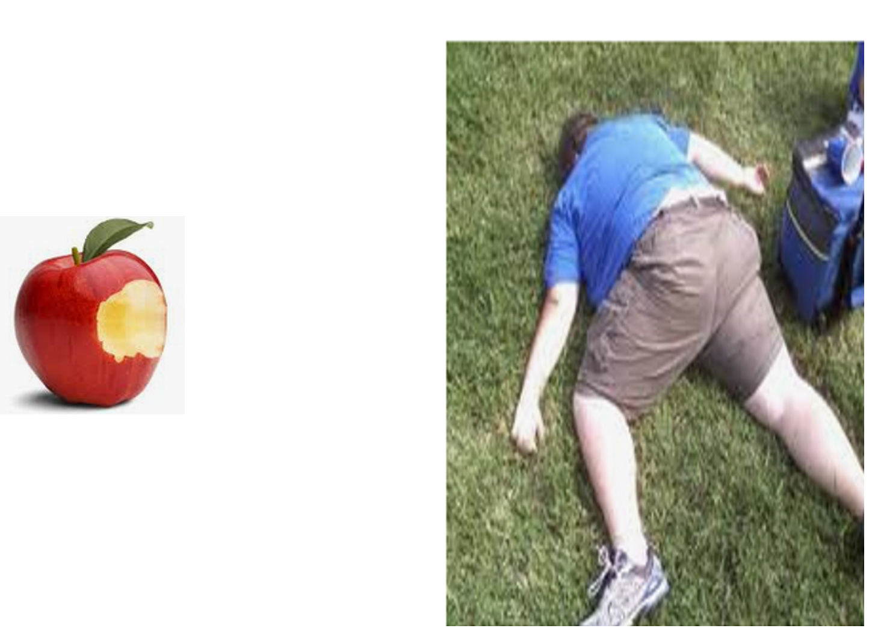
A bag of various contents is provided which provides clues to be able to estimate a time of death.
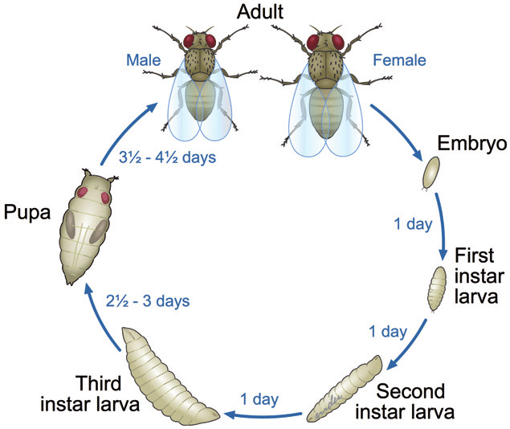
Drosophila life cycle

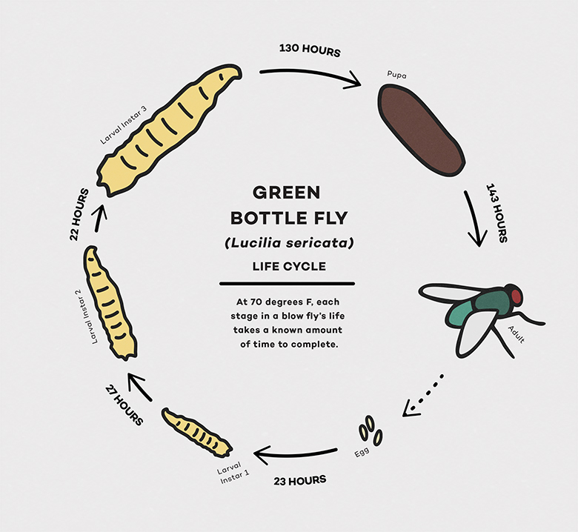
Blow fly life cycle

